**WIRESHARK LAB 1 – INTRO**

**IT 520-A – Enterprise Infrastructure & Networks**

**CHIBUNZE UZO**

1. The internet address of my computer from Fig. 1.1 below is 10.0.0.164

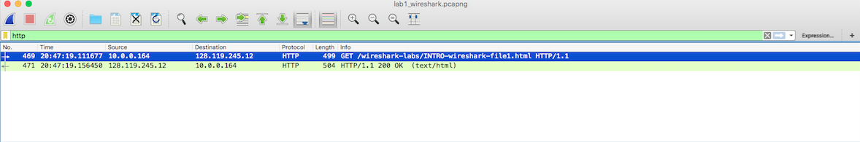

**Fig. 1.1**

1. Three different protocols that appear in the protocol column are

* TCP
* HTTP
* DNS

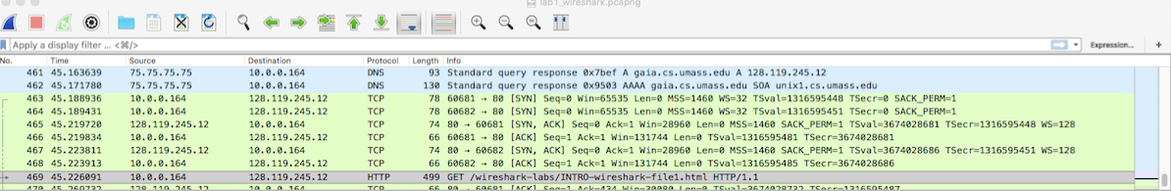

**Fig. 1.2**

1. The time it took when the HTTP GET was sent until the HTTP OK reply was received is 0.44773sec. I just subtracted the HTTP OK time from the HTTP GET time ( 20.47.19.156450 – 20.47.19.11677) to get my answer.



**Fig. 1.3**

1. The internet address of the gaia.cs.umass.edu is 128.119.245.12

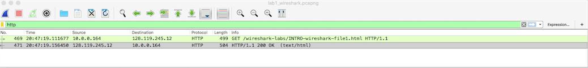

**Fig. 1.4**